***Diligent Recruitment Plan*** Missouri 2021 APSR - Attachment B

Section 422(b)(7) of the Social Security Act requires that the state provide for the diligent recruitment of foster and adoptive families who reflect the ethnic and racial diversity of children in the state for whom foster and adoptive homes are sought. There are no prohibitive policies or laws in Missouri that limit the state’s ability to recruit foster and adoptive parents who reflect the diversity of children in Children’s Division’s custody. In Missouri, targeted recruitment strategies occur statewide, initiated by the local office based on the needs of each child as well as general recruitment efforts throughout the state.

To plan for years 2015-2019, Missouri took a collaborative approach of engaging private and public partners in considering the questions posed in the Diligent Recruitment Navigator provided by the Children’s Bureau as developed by the NRC for Diligent Recruitment at AdoptUSKids. During 2015 meetings continued with the following groups to illicit input on the most effective collaboration for recruitment planning:

* Adoption Resource Centers in Kansas City, St. Louis, Central Missouri and Springfield
* Resource Team of Southwest Missouri
* Cornerstones of Care Recruitment and Retention Privatization Contractor in Kansas City and the Northwest Region
* Global Orphan Project in Kansas City and the Northern region
* Adoption Exchange of Missouri
* Recruitment and Retention Workgroup
* CFSR Advisory Committee
* Missouri State Foster Care and Adoption Board

During these meetings many of these groups were asked to identify a representative to attend the statewide recruitment committee in 2015-2019. Not all groups were asked to provide a representative as they were interested in providing feedback within their ongoing meetings and requested updates as the plan develops. In addition to the representatives identified the team is comprised of standing members including:

* Staff from the Adoption Exchange of Missouri
* Communications Director from the Department of Social Services
* Foster Care/Adoption Manager
* Quality Assurance/COA Manager and a QA/QI Field Staff Representative
* Quality Improvement Unit Manager
* Privatization contract representative
* Private case management contract representative

During 2016 and continuing through 2018, the report out and planning occurred as part of the ARTS Adoption Recruitment Training and Supports Team as a central meeting attended by partners sharing this common focus. This meeting is attended by both private and public partners as well as contractors such as the Adoption Exchange and representatives from the Adoption Resource Centers and Recruitment and Retention Contractor.

Data Gathering:

In response to the questions posed to each of these groups using the Diligent Recruitment Navigator the following data was compiled to enhance recruitment efforts. In addition to these data points Quality Assurance staff provides local reports upon request such as zip code information or school district codes and specific point in time demographic information to tailor information to specific recruitment activities and the groups in attendance. In addition to the data points below, determining the reasons foster parents stop fostering, other than adoption, is a focus of the recruitment and retention pilot, the state foster and adoption board and monitored through surveys of foster parents who cease fostering to make adjustments to training and retention methods.

**Statewide Resource Family Data 4/30/20**

**Foster and Adoptive Homes**

|  |  |  |  |  |
| --- | --- | --- | --- | --- |
|  | **Total Homes** | | **Homes with Availability** | |
|  | **Foster Homes** | **Adoptive Homes** | **Foster Homes** | **Adoptive Homes** |
| Kansas City | **344** | **1221** | **175** | **375** |
| Northeast | **596** | **1043** | **376** | **340** |
| Northwest | **345** | **835** | **209** | **249** |
| Southeast | **550** | **1302** | **290** | **215** |
| Southwest | **869** | **2138** | **508** | **692** |
| St Louis | **518** | **1282** | **314** | **366** |
| Total | **3222** | **7821** | **1872** | **2237** |

**Foster Parent Race by Region – total homes**

|  |  |  |  |  |  |  |  |
| --- | --- | --- | --- | --- | --- | --- | --- |
|  | White | Black/African American | American Indian | Asian | Native Hawaiian | Multi-Racial | Unknown |
| Kansas City | **342** | **129** | **1** | **8** | **0** | **6** | **53** |
| Northeast | **855** | **62** | **0** | **3** | **1** | **4** | **57** |
| Northwest | **545** | **19** | **2** | **4** | **0** | **6** | **32** |
| Southeast | **840** | **49** | **0** | **3** | **0** | **2** | **49** |
| Southwest | **1358** | **23** | **3** | **4** | **2** | **3** | **117** |
| St Louis | **387** | **308** | **0** | **5** | **1** | **3** | **29** |
| Total | **4327** | **590** | **6** | **27** | **4** | **24** | **337** |

**Foster Parent Race by Region - of homes with availability**

|  |  |  |  |  |  |  |  |
| --- | --- | --- | --- | --- | --- | --- | --- |
|  | White | Black/African American | American Indian | Asian | Native Hawaiian | Multi-Racial | Unknown |
| Kansas City | **198** | **53** | **1** | **5** | **0** | **4** | **20** |
| Northeast | **544** | **40** | **0** | **3** | **1** | **2** | **34** |
| Northwest | **323** | **15** | **2** | **4** | **0** | **4** | **18** |
| Southeast | **425** | **28** | **0** | **3** | **0** | **0** | **29** |
| Southwest | **230** | **199** | **0** | **5** | **0** | **0** | **11** |
| St Louis | **788** | **15** | **0** | **3** | **2** | **2** | **57** |
| Total | **2508** | **350** | **3** | **23** | **3** | **12** | **169** |

**Adoptive Parent Race by Region – total homes**

|  |  |  |  |  |  |  |  |
| --- | --- | --- | --- | --- | --- | --- | --- |
|  | White | Black/African American | American Indian | Asian | Native Hawaiian | Multi-Racial | Unknown |
| Kansas City | **1123** | **479** | **7** | **8** | **0** | **12** | **221** |
| Northeast | **1147** | **84** | **1** | **1** | **0** | **7** | **197** |
| Northwest | **1198** | **62** | **3** | **3** | **5** | **10** | **143** |
| Southeast | **1997** | **74** | **2** | **1** | **0** | **7** | **156** |
| Southwest | **3206** | **40** | **8** | **2** | **0** | **14** | **376** |
| St Louis | **808** | **816** | **5** | **1** | **2** | **11** | **140** |
| Total | **8851** | **1555** | **26** | **16** | **7** | **61** | **516** |

**Adoptive Parent Race by Region - of homes with availability**

|  |  |  |  |  |  |  |  |
| --- | --- | --- | --- | --- | --- | --- | --- |
|  | White | Black/African American | American Indian | Asian | Native Hawaiian | Multi-Racial | Unknown |
| Kansas City | **356** | **129** | **6** | **1** | **0** | **2** | **64** |
| Northeast | **503** | **19** | **1** | **0** | **0** | **1** | **54** |
| Northwest | **382** | **13** | **1** | **1** | **1** | **5** | **28** |
| Southeast | **340** | **18** | **0** | **0** | **0** | **0** | **18** |
| Southwest | **220** | **247** | **3** | **1** | **0** | **1** | **29** |
| St Louis | **1058** | **12** | **4** | **2** | **0** | **4** | **101** |
| Total | **2859** | **438** | **15** | **5** | **1** | **13** | **294** |

Note: When homes are dually licensed, counts are unduplicated for each type of resource home.

**Statewide Alternative Care Population Data:**

|  |  |  |  |  |  |  |  |  |  |  |  |  |  |  |  |  |  |  |  |  |  |  |  |  |  |  |  |  |  |  |  |  |  |  |  |  |  |  |  |  |  |  |  |  |  |  |  |  |  |  |  |  |  |  |  |  |  |  |  |  |  |  |
| --- | --- | --- | --- | --- | --- | --- | --- | --- | --- | --- | --- | --- | --- | --- | --- | --- | --- | --- | --- | --- | --- | --- | --- | --- | --- | --- | --- | --- | --- | --- | --- | --- | --- | --- | --- | --- | --- | --- | --- | --- | --- | --- | --- | --- | --- | --- | --- | --- | --- | --- | --- | --- | --- | --- | --- | --- | --- | --- | --- | --- | --- | --- |
| Total Alternative Care Population as of 4/30/20   |  |  |  | | --- | --- | --- | | **Gender** |  |  | | Females | 6722 | 48% | | Males | 7202 | 52% | |  |  |  | | **Race** |  |  | | White | 9932 | 71% | | African American | 2689 | 19% | | Amer. Indian/AK Native | 70 | 1% | | Asian | 26 | <1.0% | | Native HI/Pac. Islander | 18 | <1.0% | | Multiracial | 327 | 2% | | Unable to Determine | 862 | 6% | |  |  |  | | **Age** |  |  | | 0-2 | 3038 | 22% | | 3-5 | 2304 | 17% | | 6-9 | 2332 | 17% | | 10-12 | 1868 | 13% | | 13-16 | 2906 | 21% | | 17+ | 1476 | 11% | | | |
|  |  |  |
|  |  |  |

Missouri does not have any federally recognized Indian tribes, which is reflected in the data above. Native children are placed with relatives who share their heritage whenever possible. In some cases, children are placed out of state with relatives. Children’s Division recognizes the need to develop families within the tribal community whether these families are within Missouri or are in adjoining states where culture may be preserved.  Much work is being done to accurately capture the population of Native children, to assure culture is being preserved and resources are available to place children. During 2018 Missouri CD completed its work with the Capacity Building Center for States and Tribes and assumed the work of building of relationships with tribes in adjoining states which represent the population of Native American’s in Missouri and continuing to build relationships with representatives from the Indian Centers in Missouri to join in delivering the ICWA Learning Experience.  (See Consultation and Coordination between Tribes and States section).

**Number of Children in Children’s Division Custody with Goal of Adoption**

**As of 4/30/20 (2,613 Statewide)**

**Age of Children with Goal of Adoption as of 4/30/20 (2,613 Statewide)**

**Length of Stay for Children with Goal of Adoption**

**As of 4/30/20 (2,613 Statewide)**

**Placement Types of Children Awaiting Adoption by Region as of 4/30/20**

|  |  |  |  |  |  |  |
| --- | --- | --- | --- | --- | --- | --- |
|  | Adoptive Home | Foster Home | Relative Home | Residential Facility | Other | Total |
| KC | 2 | 153 | 92 | 29 | 25 | 301 |
| NE | 0 | 75 | 48 | 39 | 6 | 168 |
| NW | 0 | 29 | 24 | 14 | 2 | 69 |
| SE | 0 | 121 | 84 | 70 | 20 | 295 |
| SW | 2 | 172 | 124 | 65 | 19 | 382 |
| SL | 0 | 147 | 94 | 39 | 3 | 283 |
| TOTAL | 4 | 697 | 466 | 256 | 75 | 1498 |

Of the children with a goal of adoption, 57.3% (1498/2613) are considered in a pre-adoptive home with their foster parent, relative or kinship provider, up from 51% in last year’s report.

As outlined in the Diligent Recruitment plan, the Children’s Division has devised several strategies aimed at continuing to meet the statewide goal of 36 percent for all children who exited care to a finalized adoption do so within 24 months of entry. The most recent performance with this measure follows. In 2017, through a review of children awaiting TPR as well as use of Rapid Permanency Reviews, it was identified a barrier to achieve this benchmark was timely TPR filing as well as an adequate number of attorneys to complete filing. This challenge is being addressed through the use of a TPR fee agreement for use with identified pre-adoptive families who are willing to file a two count petition for TPR and adoption in cases where there will be no opposing petitions. Additional advances for the completion of TPRs were made with the Permanency Attorney Initiative and also the Rapid Permanency Reviews referenced in other sections of this plan.

In addition to the items outlined for recruitment, local circuit meetings continue to be held with Juvenile courts to address procedures for filing of Termination of Parental Rights (TPR) petitions. Access to legal representation has also been improved for CD staff through a joint memorandum and protocol with the Division of Legal Services. As a result of efforts to recruit resources to meet the needs of the children who await adoptions and the efforts to assure TPR’s are completed appropriately and timely, the finalized adoptions for SFY 2019 increased 4.9% from the previous fiscal year.

|  |  |
| --- | --- |
|  | Number of Finalized Adoptions |
| SFY 12 | 1,148 |
| SFY 13 | 1,222 |
| SFY 14 | 1,250 |
| SFY 15 | 1,315 |
| SFY 16 | 1,524 |
| SFY17 | 1,588 |
| SFY18 | 1,740 |
| SFY19 | 1,826 |

**Ongoing Recruitment Efforts:**

The Division has refined and expanded the social media presence during 2017 utilizing Facebook, Twitter, the Social Services homepage and MO Heart Gallery website more consistently to promote foster care, adoption and events specific to recruitment and support of resource parents. The multifaceted approach includes:

* Person to person contacts by current foster/adoptive parents with potential foster/adoptive parents which has proven to be the single best method for recruitment. Social media features make information sharing seamless for resource parents to share with their social groups/contacts,
* Recruitment of distinct individuals based on profession or prior involvement with a child as mandated by a child’s special need,
* Community informational meetings and events to educate about foster care and adoption (shopping malls, fairs, libraries, bookstores) featuring the Missouri Heart Gallery and recruitment materials,
* The news media (newspapers, radio station, television station, cable network station, special interest bulletins), including expanding Wednesday’s child features into the Springfield television market in 2017,
* Displaying flyers, pamphlets, posters, handouts and electronic web notices and social media posts,
* Coordination with faith-based partners in communities throughout the state to feature photos and profiles of children currently waiting for adoption and informing churches of the need within their community for foster and adoptive families by providing zip code specific information to the faith-based partners for recruitment,.
* Coordination with faith-based partners also has resulted in increased support of relative and non-relative resource families and through this support has increased interest in providing care as a foster parent,
* Distribution of informational packets and foster parent information in Heart Gallery promotion materials at recruitment and community events
* Utilizing AdoptUSKids site and the Adoption Exchange websites where Missouri’s waiting children are featured in addition to the MO Heart Gallery site
* Celebrating National Foster Care month (May) and National Adoption month (November) and including media campaigns and print materials for recruitment
* Linking Hearts Event in Rolla MO which is a collaborative effort between the Phelps County Community Partnership and the Panhellenic Society at Missouri S and T University. This is an effort to have families interact with available children and receive information about foster care and adoption.
* National Recruitment Saturday Celebration in St. Louis County and Jackson County.
* Journey Home Bus Tours to heighten awareness and recruit families.

Policy and practice changes that were incorporated in FY 2017 included:

* Maintenance Payments for Resource Payments continue when the foster youth temporarily leaves the placement for hospitalization, camps or visits when the youth will return to the resource home following the temporary absence
* Additional Respite Unit Approval up to 20 units with supervisor approval and approval for units in excess of 20 at the discretion of the regional director or designee to further support placement stability
* Addition of Sibling Tracking in FACES which assists in identifying potential relative or resource parents for children entering care
* New Definition of Relative Foster Care consistent with a revision of the relative definition: “*relative” means a grandparent or any other person related to another by blood or affinity or a person who is not so related to the child but has a close relationship with the child or the child’s family.”* (Revised Missouri Statute 210.565)
* Announcement of Children’s Division Data Dashboard which provides high level data including tracking permanency in 12 months, length of time to adoption, length of time to guardianship, placement stability and percent of children residing in residential placement settings. Measures for the length of time between entry and filing of TPR and the length of time between filing TPR and finalized adoption are being developed.
* Foster Care Bill of Rights containing seven items which reinforce the Children’s Division mission and goals and informs youth of their rights as foster youth.

During 2016 the Division took a closer look at the Heart Gallery process and partnered with the Adoption Exchange to streamline the process. Registration for the Heart Gallery is now open year round. Photographers are initially contacted by The Adoption Exchange to have children assigned to them. Each region of the state has a contact person assigned to help with communication between the worker and photographer to arrange time and location.

Photographs are now printed twice a year, for the traveling Gallery. Each region receives an 8x10 image of the children from their region who are featured in the Gallery for display at their events. The Adoption Exchange has a new look and updated registration process. For children to be listed on The Adoption Exchange website, staff now complete a new on-line registration or relist if a child is already on the site. When registering a child, staff now have the option to choose registration with the Adoption Exchange, AdoptUSKids and the Missouri Heart Gallery at the same time. Prospective adoptive families are directed to the online Heart Gallery for a complete list of children featured. Regions also receive extra images of children from other regions and have the flexibility to exchange with other regions. The Children’s Division is continuing to hold focused grassroots efforts at events such as PTAs, fairs, and churches, etc.

In 2016 the new platform was launched as described above and in 2017 a long awaited goal was achieved with addition of video segments/digital stories added to a number of profiles featured on the Gallery.

In 2018 quarterly meetings continued with the Diligent Recruitment Team, as part of the agenda of the ARTS team, developed in the first year with the intent to continue to plan ongoing and additional recruitment strategies and share information amongst team members of successful recruitment activities and feedback on the recruitment materials and strategies being used.

Continued coordination occurred with the Adoption Exchange to:

* Further expand their role in recruitment of foster and adoptive parents for youth.
* Increase connections for youth in foster care and awaiting adoption through targeted recruitment meet and greets with waiting youth and waiting families with similar interests
* Increased features of video/digital profiles on Adoption Exchange and Heart Gallery websites to bring the waiting children’s personalities and interests to life.

Due to the combination of support of the Heart Gallery activities, the FIT activities and features of youth on AdoptUSKids a new request was slated for release in 2018, however, this release was delayed until April 2019. Until the request can be awarded the contract continues with the Adoption Exchange to provide these services under contract extensions. The contract RFP includes development of the video/digital stories in addition to the remaining contract requirements.

RPC (Resource Parent Curriculum) from the National Child Traumatic Stress Network was offered throughout 2018 and into 2019.

Outreach was expanded by current foster and adoptive parents in recruitment of new resources using the demonstrated strategies by partners on the Diligent Recruitment Team. These strategies were refined based on the information provided by the data shared to assure families are being recruited consistent with the demographic makeup and needs of the alternative care population and in turn the subgroup of that population awaiting permanency through an adoptive home.

Additional electronic or media profiles to developed and presented in local television markets and subsequently posted on the Heart Gallery website and social media platforms for featured children.

Continued partnership with Faith and Community Partners to:

* Ensure outreach to all communities representative of the youth population in care.
* Accomplish outreach to neighborhoods for development of resource homes where children are removed to ensure children can remain in close proximity to family, school and social connections.
* Recruit families committed to preserving Native American/Alaskan Native culture for children/youth with such cultural background which is being accomplished through partnership of the ICWA workgroup.
* Support the Recruitment and Retention contractor in their MOU with the Keep in recruiting, supporting and maintain resource homes who are provided support from their church congregation.
* Operationalize the terms of the MOU developed with YMCA to utilize YMCA locations to feature children awaiting adoption, promoting recruitment of foster and adoptive families. It also serves to institute a process for making families aware of the YMCA provision of reduced membership rates to resource families and youth in appreciation for their service and support of their physical and mental health.
* Website redesigned to allow families interested in becoming resource parents as well as current resource parents’ access to relevant and helpful information easily.

In 2017 the Division held listening sessions with resource parents and staff. The purpose of these sessions was to focus on supports needed to retain families, strategies to recruit resource families for older youth, youth with elevated needs and sibling groups. In addition to the listening sessions, exit interviews were conducted with a sample of families who have closed their resource license to determine the reason behind closure. It is the intent and hope of these sessions and interviews to glean information to inform the Division and its contractors of adjustments needed to retain quality families. Then First Lady Sheena Greitens conducted town hall meetings with foster parents to also gather information about their experiences.

As a result of information shared as well as a presenting opportunity, the CD has joined with Northeastern University and the National Council for Adoption in surveying resource parents at seven points in their foster care journey from expressing an interest to closing their license. Information from this survey will be used to refine recruitment, assessment, training, supports throughout foster care and adoption.

Ongoing efforts for 2019:

Progress to achieve goal of 50% or more placement rate of children in foster care with relatives, CD is focusing significant energy on relative assessment, training and supports. In early 2019 a designated Relative First Program Development Specialist was added to the team in CD Central Office to spearhead this work. In 2018 Missouri was fortunate to have the National Family Focused Treatment Association (FFTA), through the Missouri chapter, facilitate a summit with Missouri CD and current Therapeutic Program Care providers to explore expansion of Therapeutic Care to Relative Providers. By late 2018 the local FFTA Chapter and Missouri Children’s Division had developed a process to pilot provision of these services under the existing contract structure. To date there are three active cases of youth residing with Therapeutic Relative providers. The Children’s Division looks forward to continuing to pilot up to 10 cases and determine the most effective strategies and processes to bring Therapeutic Relative Treatment into the available service possibility for all relative children requiring a higher level of care at entry or as stepdown from residential care. Incorporation of Signs of Safety into resource licensing which has begun with introduction of Signs of Safety maps to be used in resource licensing and assurance all information necessary to meet licensing standards is captured on the map or in the FACES system. Work is ongoing to include Signs of Safety philosophy into policy and practice development to keep up with the field work being accomplished. In November 2018 the Children’s Division was accepted as a pilot site for the National Training Development Curriculum project through Spaulding for Children who was awarded a 5-year cooperative agreement from the Children’s Bureau. The grant is being used to develop and evaluate a state of the art training program to prepare foster and adoptive parents to effectively parent children exposed to trauma and to provide these families with ongoing skill development needed to understand and promote healthy child development. As a participant of the project Missouri will have access to a free, comprehensive curriculum that has been thoroughly evaluated to be used to prepare resource parents. The training includes a foster, relative and adoptive track. As a result of this notification, Missouri decided to put energy being spent on refinement of pre-service and in-service trainings into development of the training with NTDC, in the meantime continuing with the existing training curriculum, STARS.

Efforts to heighten awareness of the need for foster and adoptive providers in National Adoption Month occurred in November. Social media was maximized for this effort with children or sibling groups featured every day in November, along with interviews of adoptive parents and staff in an effort to recruit. Adoption month bracelets were purchased and shared with community partners as conversation starters at each of the events held in local jurisdictions.

As a result of the Family First Legislation passage, Missouri CD is contracting with ParentLink to provide Kinship Navigator Services to relative providers. The navigator services will be available to both formal and informal kinship providers. The contract with ParentLink requires a steering committee to include management of Missouri’s Adoption or Family Resource Centers to assure combined efforts for relative care providers and cross pollination of support or retention services provided to relative and non-relative resource families where appropriate.

Also as a result of the Family First Legislation, the Division is focusing heavily on recruitment of resource homes to assure resources are available for elevated needs children when they enter care in place of the need for residential care and also as a strategy to discharge youth from residential treatment and assure timely permanency. Jackson Co. began a right sizing residential group consisting of Children’s Division representatives, Foster Care Case Management Partners as well as the Privatized Recruitment and Retention Contractor to develop solutions and strategies for developing family settings for children. The group has worked to assure Department of Mental Health services are accessed, connected relatives and foster families to Tools of Choice training through DMH to prepare and equip them for elevated needs youth.

Additional efforts in 2019 include:

* Awarding the RFP for Adoption and Foster Care Recruitment Services which will increase presentation of available children for adoption on the AdoptUSKids, Adoption Exchange and Missouri Heart Gallery Websites as the primary goals. Secondary goals will be use of the profiles written and photos taken for each of these sites for targeted recruitment for children awaiting adoption. The awarded RFP will increase the numbers of digital stories or media spotlights to be added to each of the sites also to bring the children’s spirits, personalities and interests to light to increase matching efforts.
* Expansion and training of staff in use of the AdoptUSKids website for reverse matching to identify potential adoptive families across the nation for our children who wait. In early 2019 five trainings have been conducted with staff to demonstrate the use of and potential for this tool in identifying families. Each of these activities designed to reduce time to permanency for children for whom an adoptive placement is being sought.
* Amplified Faith Based Recruitment of Foster and Adoptive homes through a fulltime Faith Based Liaison within the Children’s Division with planned outreach to large church congregations to focus on recruitment as well as support of resource parents for retention.
* Focus Groups as part of the Survey Project with the National Council for Adoption and Northeastern University to inform the project data and allow for refinements to the retention strategies of the Children’s Division and its private contractor.
* Development of new messaging consistent with Family First to wrap services around intact families as the first recruitment strategy, followed by support of relative providers through the Navigators and Family Resource Centers and enlistment of community volunteers, recruitment of resource parents for elevated needs children and youth to allow for stable caregiving for children entering care with elevated needs or stepping out of the residential setting to a resource home and support for each of these placement types.
* Adoption Placemat work under the direction of the Adoption Program Specialist. The adoption placemat is intended to increase the number of prospective adoptive resources so all children in need of a permanent home have an adoptive family to achieve timely permanency when they cannot be reunified with their family. This work will be achieved through the following steps: 1) increased support to field staff to assure accurate capture of goals and pre-adoptive placement to assure the waiting child pool is accurately identified, 2) use recruitment strategies of features on social media, websites, web matching events, targeted recruitment efforts and maximizing involvement of Child Placing Agency partners, 3) assure staff are using the tools available for reverse matching through AdoptUSKids and finally 4) assuring petitions for TPR and adoption are filed promptly to assure timely permanency.

New Efforts in 2020-2024

* Use information from the NCFA survey data including focus group information to identify the most effective venues for recruitment of resource parents and assure information is available in each of these venues.
* Evaluate the effectiveness of the new messaging or community ask for family support, respite providers as well as foster and adoptive families being developed in 2019 to assure the messaging resounds with potential supports and resources and make refinements as indicated.
* Focus on recruiting families who can support reunification of children through support of biological family.
* Continue work with National Training Development Curriculum project to tailor the training message specific to Missouri populations and identified training or support gaps. Assure the training can be delivered to all populations regardless of reading level or language requirements. Develop the Missouri specific portions of the NTDC to assure each family receives training and supports in a consistent manner.
* Continued and ongoing training of staff use of the reverse search of the AdoptUSKids website to identify potential families for children needing an adoptive home concurrent with searches of Missouri homes for placement, breaking down jurisdictional barriers.
* Determine a methodology for comparing alternative care population and waiting child population to determine the number of homes needed and preparation level needed for those homes to assure capacity for children of all need levels using and refining current data available as included in this plan as well as the data reports in the Recruitment and Retention Contract section of the APSR
* Expanded use of Extreme Recruitment and Family Finding efforts to assure children in need of a permanency other than reunification can have that permanency with family.

**2019 Diligent Recruitment Plan Update:**

During 2019, the Children’s Division has used the information from the National Council for Adoption (NCFA) survey data in the work being done with recruitment, licensure and support of resource homes in Missouri. This work has been accomplished through the work of the Diligent Recruitment and Recruitment and Retention Reboot workgroups and in collaboration with the Recruitment and Retention Contractor and the partner agencies. Because of the Division’s involvement with NCFA and the pilot with National Training Development Curriculum (NTDC), Missouri is working with these groups to move the survey into two additional regions, Southwest and Southeast Missouri, for evaluation to take place in comparison of the NTDC to a newly developed Missouri curriculum being used in those two regions. This evaluation will also allow a third prong evaluation through the comparison group for the evaluation being conducted for the control group for NTDC, which is the current STARS/PRIDE region in the Northeast and St. Louis. In 2020-2021, valuable learning opportunities are anticipated from this combined evaluation, which will afford the opportunity to identify the best training and supports strategies for Missouri resource families.

During 2019, Children’s Division was committed to evaluating recruitment messaging, developing a new recruitment logo, video and recruitment card. The new logo was developed for foster care recruitment as well as the Missouri Adoption Heart Gallery, which are posted below, and new video was developed for release during foster care month in May with the link also pasted below.

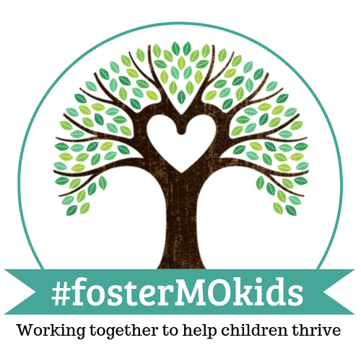

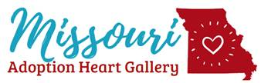

Video [https://youtu.be/F_P5m-PUc-Q](https://urldefense.proofpoint.com/v2/url?u=https-3A__youtu.be_F-5FP5m-2DPUc-2DQ&d=DwMFaQ&c=GSntNbUav5AC0JJIyPOufmfQT3u3zI7UKdoVzPd-7og&r=Zq_ttVwhOqHpO2GVX9x88UXQSF08GP-Vxw9TsnDQEqQ&m=r2DAs92V319gFQxQRd5CELVLJ8uTPTuneIubmiPleiA&s=hCmFM9MnGUwT2mlRjUJ-RDfGMwKEvbod238_uoofzEs&e=)

During 2019 trainings were conducted for field staff on use of the AdoptUSKids application to accomplish a cross match of families with available waiting youth. Staff found value in this training and identified many potential placements for staff to follow up with after training.

In the 2019 year, Missouri met the goal of expanding use of Extreme Recruitment and Family Finding in the central region, which is executed from the Family Resource Centers.

Missouri Children’s Division continues to hover at 50% of placements with relatives. As of the writing of this report, placements with relatives was 49.7%. During 2020-2024 the Children’s Division will continue to strategize on how to achieve the goal of over 50% knowing that placements with relatives are more stable, and reunification occurs more expeditiously than placements with foster parents. With the addition of the Missouri Kinship Navigator program through Parentlink and the Missouri Family Resource Centers, needs of families are being clearly identified allowing ongoing work in 2020-2024 to focus on consistent delivery of services to address the identified needs as well as striving to have equal access throughout the state to every available resource.

Children’s Division has also been very pleased with the work in 2019 of developing and expanding Foster Care Neighborhoods around the state. In these neighborhoods, licensed resource families live in adjacent homes within one neighborhood that is provided support by a licensing agency. The families are provided the necessary support to maintain placements and be successful with children by their neighbor foster parents as well as therapeutic supports, and training provided by the support agency. This model has resulted in foster care placements made into these neighborhoods being stable and the children and youth having the opportunity to build supportive relationships with their foster family, the neighborhood and the support staff. In 2020-2024 work will continue with the existing neighborhoods and assist with development of any additional neighborhoods agencies are interested in sponsoring.

Missouri has participated in both of the Adoption Call to Action Summits hosted by the Children’s Bureau. In preparation for the summit in August, the data below was compiled for review, discussion and planning.

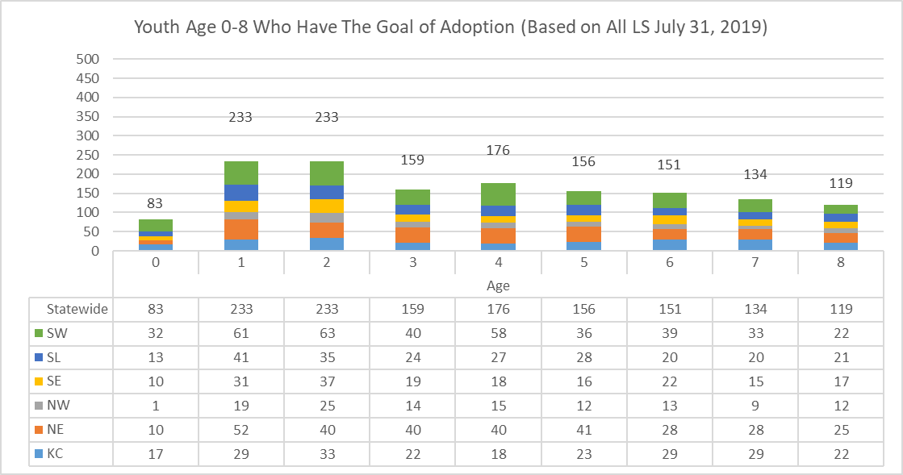

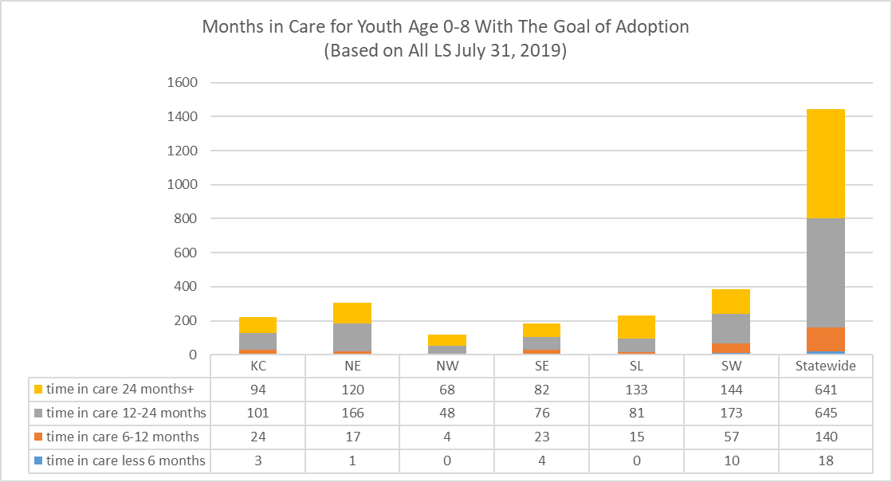

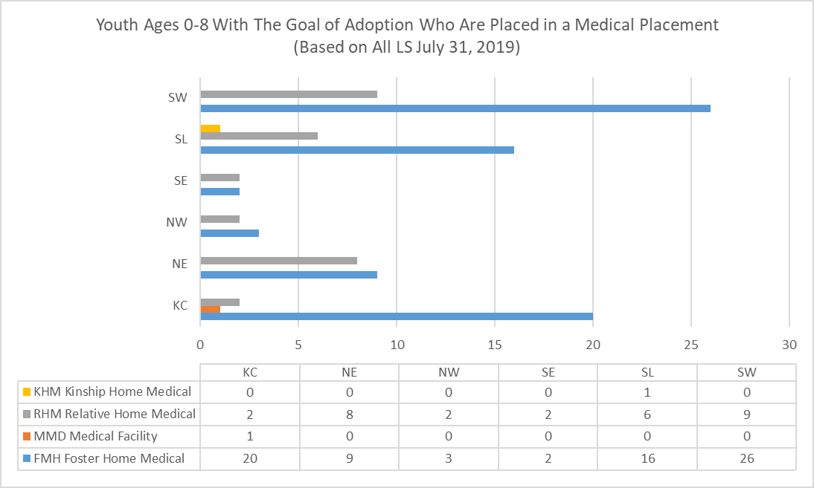

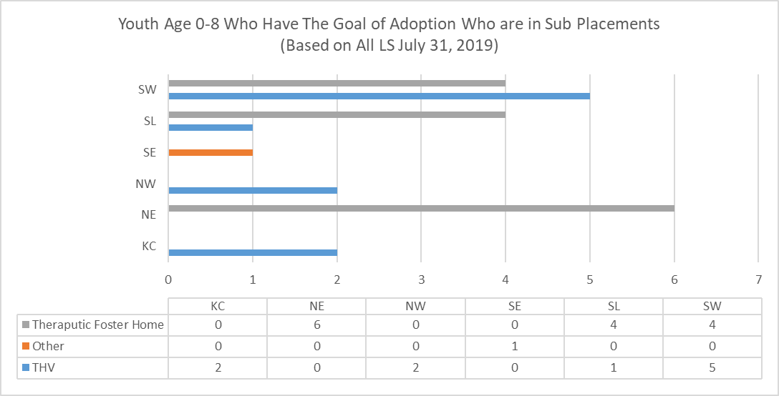

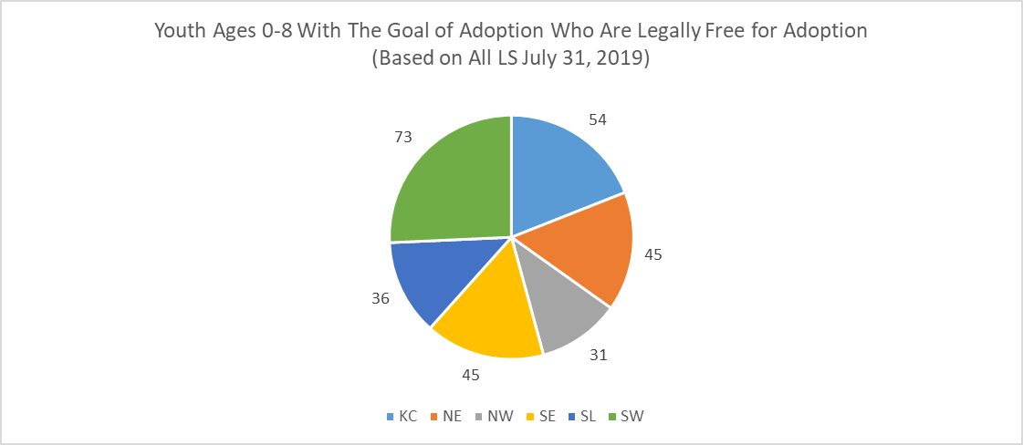

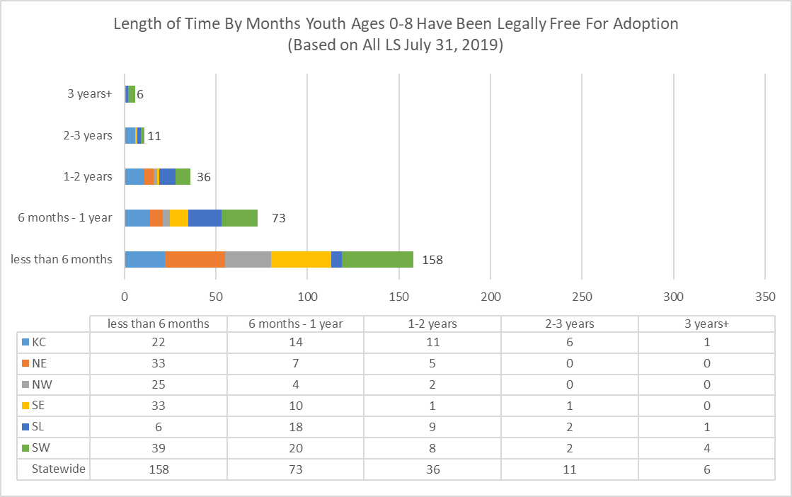

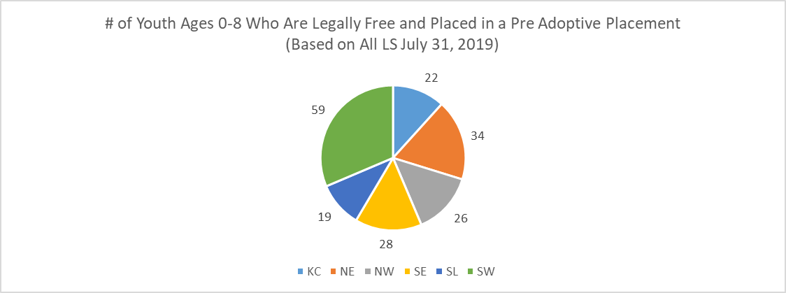

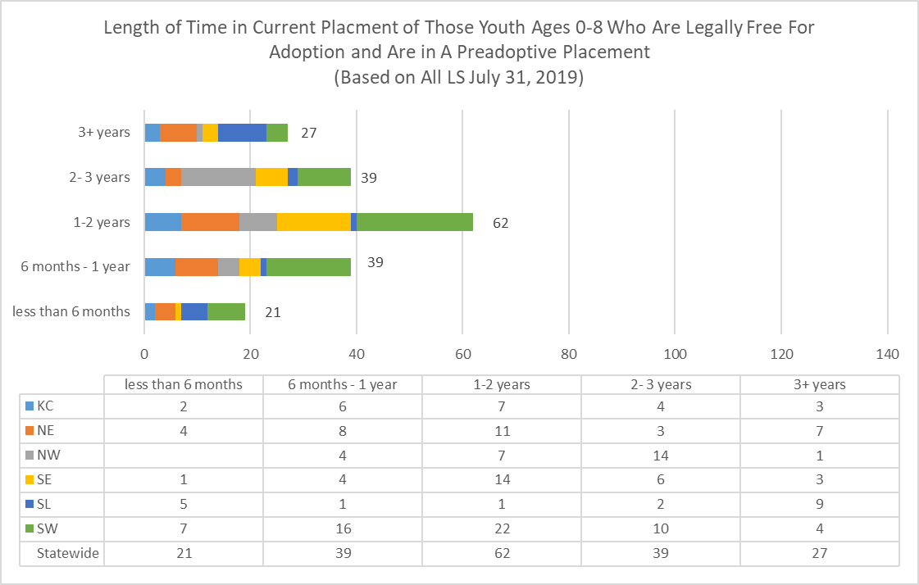

Following the initial summit, Missouri Children’s Division was committed to continuing the goals of:

* Expanding Extreme Recruitment, 30 Days to Family and Family Finding,
* Messaging for recruitment of foster and adoptive families as well as individuals willing to address the needs of the Division and the families served,
* Increasing relative placements consistent with the goals of this Diligent Recruitment plan while focusing the recruitment on the populations identified in the data.

Following the adoption Call to Action Summit #2 in January Children’s Division has been focusing on the work of Missouri Permanency Attorney Initiative to reduce time to permanency. The Division has recognized that delays to permanency through reunification, adoption or guardianship exist due to a lack of legal representation to resolve the cases. The permanency attorney initiative has been touted as moving cases more quickly to permanency. The goal of this action item was to determine if assumptions were accurate and what refinements needed to be put in place to result in optimal success. Work is ongoing in 2020 to quantify the outcomes. Work began in developing logic for the comparison and tested the comparison of cases being served by a permanency attorney vs. cases not served by a permanency attorney. In this comparison, a significant reduction in the number of days to permanency for children managed by the foster care case management contractor in the largest region in Missouri was found.

|  |  |  |  |  |
| --- | --- | --- | --- | --- |
|  | Days in Care | Days to Closed after PAI | Non-PAI Days in Care | Days to closed after non-PAI ** |
| Average Days | 697 | 152 | 903 | 211 |
| Median Days | 720 | 94 | 608 | 209 |
| Minimum | 18 | 11 | 5 | 4 |
| Maximum | 2944 | 699 | 5740 | 404 |
| **TOTAL COUNT: 44 Cases** | **44 Cases** | | **31 Cases** | |

**Compares non-PAI case that was active to corresponding PAI case at the time of PAI assignment

The next step will be to compare the population served by the Children’s Division in the St. Louis area consistent with the work completed for the contracted providers. The intent of this exercise is to use data to support and advocate for additional attorneys to assure timely permanency.

Because of work on permanency, in SFY19 1,826 adoptions finalized demonstrate an increase in adoptions in Missouri for an eighth year.

|  |  |
| --- | --- |
|  | Number of Finalized Adoptions |
| SFY 12 | 1,148 |
| SFY 13 | 1,222 |
| SFY 14 | 1,250 |
| SFY 15 | 1,315 |
| SFY 16 | 1,524 |
| SFY17 | 1,588 |
| SFY18 | 1,740 |
| SFY 19 | 1,826 |

Work will continue in 2020-2024 on the goals identified in this plan and collaborative efforts outlined.